Michael Weaver

CST – 235

Brandon Bass

12/10/17

**Short Assignment 5**

GitHub Link: <https://github.com/battousairurik/CST-235>

**Assignment Approach**

The first attempt at this assignment resulted in numerous different completion methods, none of which could be compiled. The servlet xml file ended up being renamed and the path broken forcing me to delete the entire project and start over from scratch.

The second iteration of the attempt was a bit more fruitful. I managed to discover the correct way to create initialization parameters by mapping them into a servlet which is called from a url. This in turn calls the class which is designed to capture the initialization parameters through the init() and goGet() methods. This is supposed to output the parameters to the screen, but it fails to even locate the page. I do not currently have the knowledge to discern the problem.

**List of Classes, Methods, Variables, etc.**

* InitParam.xhtml
* Web.xml
* ReadInitParamServlet.java

**Screenshots**

Parameters

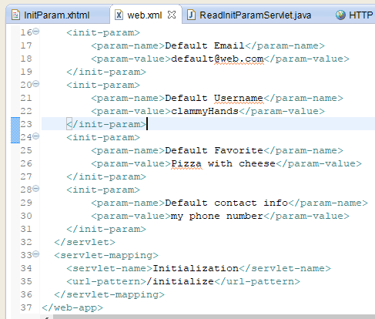

Results

